**Assignment 2**

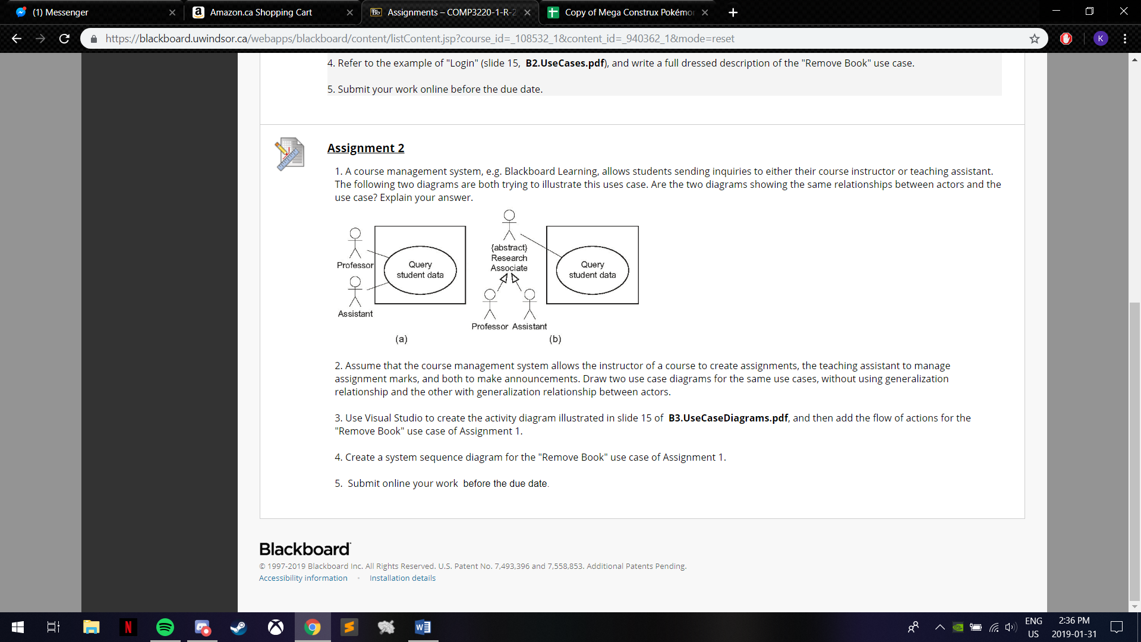1. A course management system, e.g. Blackboard Learning, allows students sending inquiries to either their course instructor or teaching assistant. The following two diagrams are both trying to illustrate this uses case. Are the two diagrams showing the same relationships between actors and the use case? Explain your answer.   

These two diagrams are showing the same relationships between actors and the use case. In diagram (b), generalization is used to simplify the use case model. The abstract method is used for easier reading of the model, linking both parts of research associate together which queries student data.

2. Assume that the course management system allows the instructor of a course to create assignments, the teaching assistant to manage assignment marks, and both to make announcements. Draw two use case diagrams for the same use cases, without using generalization relationship and the other with generalization relationship between actors.

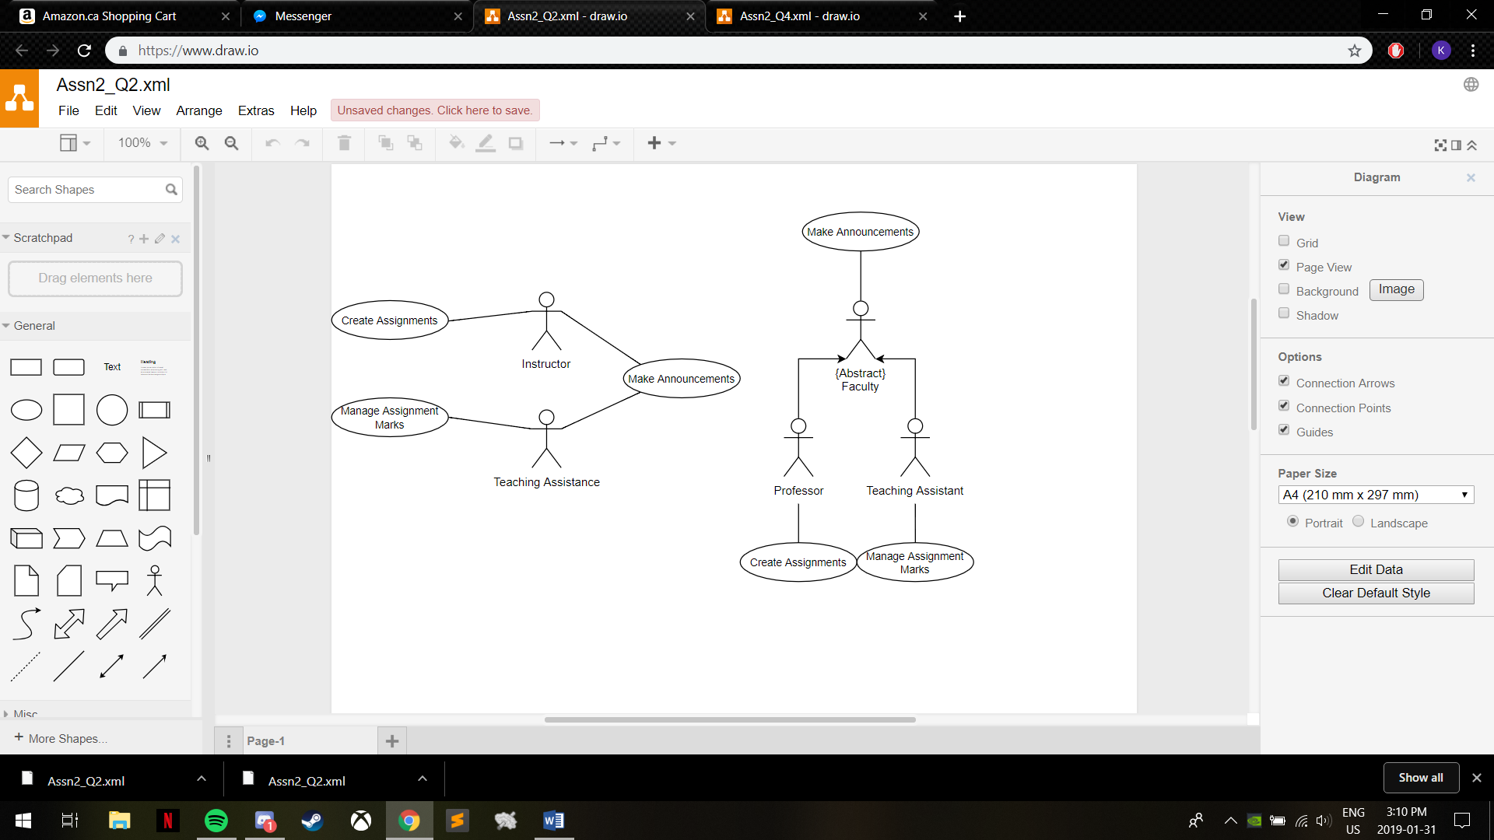

3. Use Visual Studio to create the activity diagram illustrated in slide 15 of  **B3.UseCaseDiagrams.pdf**, and then add the flow of actions for the "Remove Book" use case of Assignment 1.

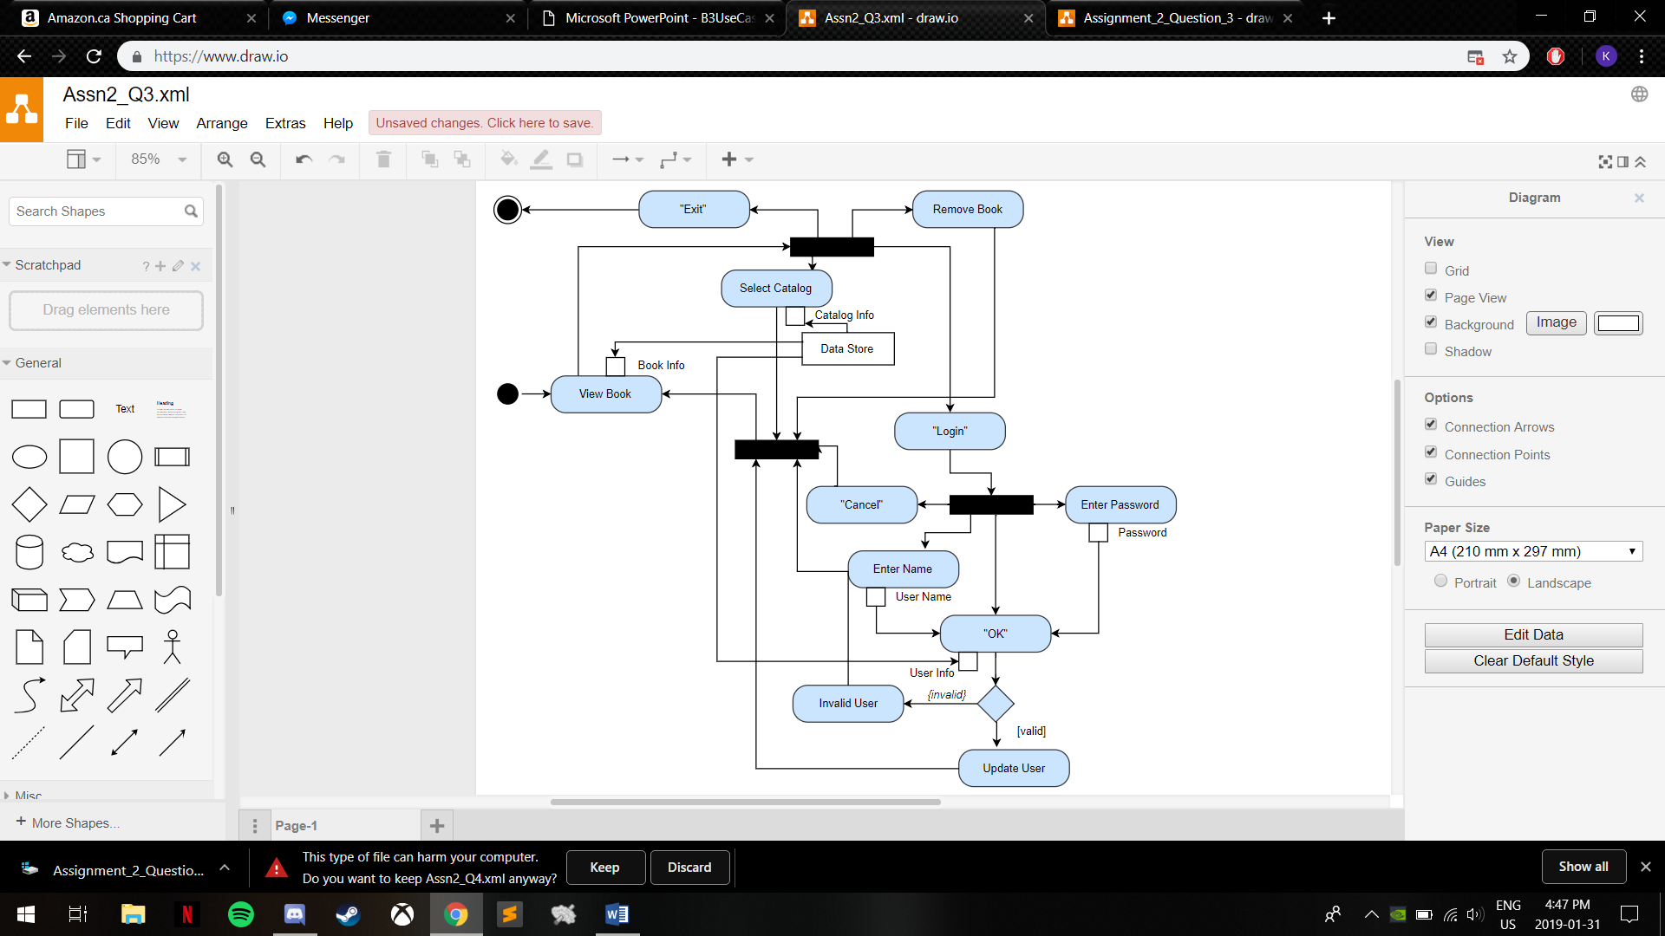

4. Create a system sequence diagram for the "Remove Book" use case of Assignment 1.

|  |  |  |
| --- | --- | --- |
| Use Case |  | Remove Book |
| Main Flow | A1  A2  A3  A4 | This use case begins with the bookstore UI that contains books in the booklist  The Customer selects a book from the current booklist  The Customer clicks the button labelled “remove”  The system removes the book from the booklist |
| Alternative Flows | A5 | The selected book is outdated or invalid in the database and cannot be removed |
| Exception | A6 | If no book is selected from the booklist, then the error message indicating that a book must be selected is displayed at the bottom of the window. |

